

**Education 6.0 | STEMMA**

**Request Meeting**

|  |  |
| --- | --- |
| Full Name |  |
| Organization / Ministry |  |
| Title / Designation |  |
| Email Address |  |
| Preferred Date & Time (calendar picker) |  |
| Time Zone |  |
| Area of Interest (Curriculum Reform, Digital Sovereignty, Skills for Future, STEMMA Integration, Other) |  |
| Purpose of Meeting / Key Questions (textarea) |  |
| Format Preference (Virtual, In-Person, Hybrid) |  |

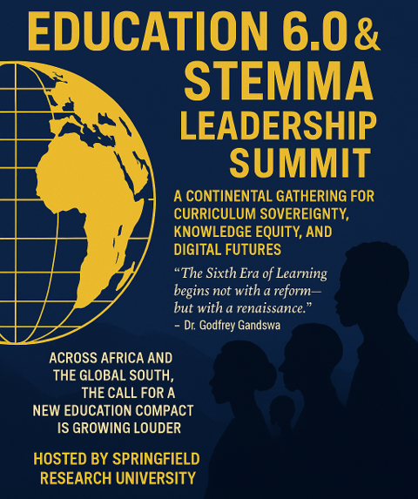

Info

+268-7619-2898

[summit@springfieldresearch.university](mailto:summit@springfieldresearch.university)

Address

Knowledge Park I, Examination Council of Eswatini,

Ezulwini Valley, Ezulwini

Eswatini

