

**Education 6.0 | STEMMA Leadership Summit**

**Request Invitation Letter**

|  |  |
| --- | --- |
| Full Name |  |
| Passport Number (optional) |  |
| Country of Citizenship |  |
| Email Address |  |
| Affiliation (Institution/Organization) |  |
| Role or Designation |  |
| Purpose of Request (Visa, Funding Approval, Internal Travel Clearance, Other) |  |
| Address Where Letter Should Be Sent (email or postal) |  |

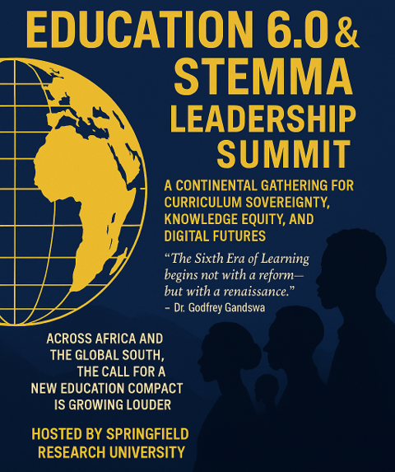

Info

+268-7619-2898

[summit@springfieldresearch.university](mailto:summit@springfieldresearch.university)

Address

Knowledge Park I, Examination Council of Eswatini,

Ezulwini Valley, Ezulwini

Eswatini

