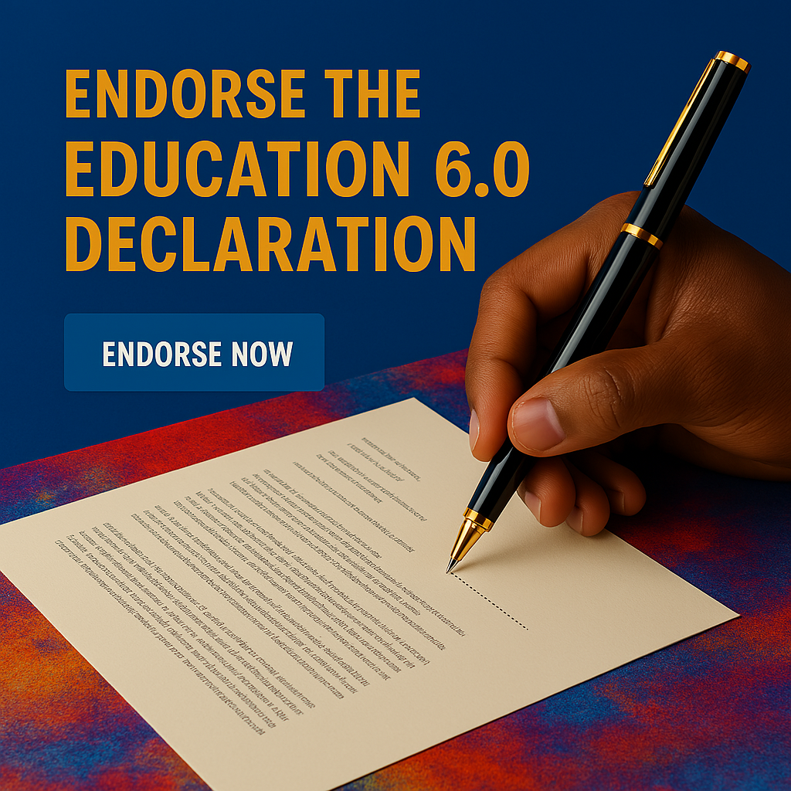

**Education 6.0 | STEMMA**

**Education 6.0 Declaration**

**Education 6.0 Declaration**

*Forging Africa’s Future through Innovation and Humanity*

**Introduction**

At this pivotal moment in Africa’s development journey, we stand face-to-face with the most powerful resource our continent has ever known: our people—especially our youth.

But to fully realize this potential, we must confront a singular truth: **Education must evolve.** It must rise beyond legacy systems, escape colonial scaffolding, and leap toward a new paradigm that is distinctly African, unapologetically innovative, and fundamentally transformative.

**Education 6.0** is not a step forward—it is a *stride into the future*. It represents a shift from standardized instruction to sovereignty-driven learning; from knowledge consumption to capability cultivation; from passive curriculum to empowered imagination.

Crafted at the intersection of **technology, cultural wisdom, and social impact**, Education 6.0 answers a generational call. It prepares youth not for exams—but for ecosystems. Not for jobs—but for building nations. Not to imitate the world—but to **redefine it.**

This declaration invites educators, institutions, policymakers, and partners to converge on this common mission: to architect an educational renaissance rooted in **ethics**, **automation**, **purpose**, and **pan-African relevance**.

It is here, through this document, that we launch the narrative.

We do not ask permission to shape the future.

**We declare it.**

*— Dr. Godfrey Gandawa*

**President, Springfield Research University**

Architect of the Education 6.0 Framework

*Advancing Sovereignty, Innovation, and Humanity through African Education*

**Preamble**  
We, the undersigned educators, visionaries, youth leaders, and nation-builders, do hereby declare that the time has come to radically transform Africa’s education paradigm—not as a reform of yesterday’s system, but as a renaissance forged for tomorrow. Education 6.0 is that renaissance.

**1. What Is Education 6.0?**

Education 6.0 is a new educational contract between society and learning. It is:

* **Human-centric**: Rooted in ethics, values, and community accountability
* **AI-driven**: Powered by emerging technologies that expand human potential
* **Place-based**: Grounded in African heritage, knowledge systems, and realities
* **Sustainability-aligned**: Structured to advance the SDGs through innovation and equity
* **Empowerment-focused**: Delivered not to inform students—but to **equip architects of the future**

**2. Why Now?**

Africa is the youngest continent with the greatest potential. Yet our education systems remain trapped in extractive models that reward memory over imagination. Education 6.0 calls for:

* A shift from **compliance to creativity**
* From **imported curriculums to endogenous knowledge**
* From **degree inflation to capability expansion**

**3. Our Core Pillars: The STEMMA Engine**

Education 6.0 is operationalized through **STEMMA**—a holistic integration of:

* **Science**
* **Technology**
* **Engineering**
* **Mathematics**
* **Medicine**
* **Automation**

But these pillars are not mechanical—they are **civic tools**, used to build societies that are healthy, wise, and sovereign.

**4. Commitments We Make**

We hereby commit to:

* Establishing *Education 6.0 institutions* and digital academies across the continent
* Embedding *AI fluency* and *digital citizenship* into core learning from early education upward
* Promoting *culturally relevant content* through curriculum codesigned with African communities
* Partnering with governments to launch *Education 6.0 legislative frameworks*
* Measuring our impact not by enrollment, but by *transformation*

**5. An Invitation to the Future**

We call on Heads of State, Ministers of Education, development partners, and Pan-African institutions to join us in charting this new roadmap. Let this Declaration the **Ezulwini Accord**—wherever it lands, let it take root in legacy.

**Signature Block**

Signed:   
*Dr. Godfrey Gandawa*  
*President, Springfield Research University*  
*Date:*

**Complete Below**

|  |  |
| --- | --- |
| Full Name |  |
| Email Address |  |
| Country/Region |  |
| Role (Educator, Policy Leader, Researcher, Media, Student, Other) |  |
| Checkbox: “I endorse the values expressed in the Education 6.0 Declaration” |  |
| Signature |  |
| Date |  |



Info

+268-7619-2898

[summit@springfieldresearch.university](mailto:summit@springfieldresearch.university)

Address

Knowledge Park I, Examination Council of Eswatini,

Ezulwini Valley, Ezulwini

Eswatini

