

**Education 6.0 | STEMMA Leadership Summit**

**Submit Your Manuscript**

|  |  |
| --- | --- |
| Full Name |  |
| Institution or Organisation |  |
| Email Address |  |
| Country/Region |  |
| Proposal Title |  |
| Proposal Type (Keynote/Policy Pitch etc) |  |
| Co-presenters or Collaborators (Optional) |  |
| Declaration of Originality |  |
| Theme Alignment |  |
| **Proposal** | |
|  | |

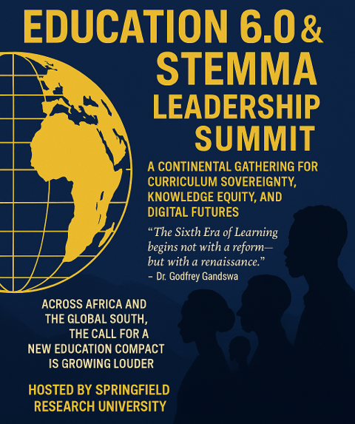

Info

+268-7619-2898

[summit@springfieldresearch.university](mailto:summit@springfieldresearch.university)

Address

Knowledge Park I, Examination Council of Eswatini,

Ezulwini Valley, Ezulwini

Eswatini

